Kommunicate Assignment

1. Design the below screen using HTML and CSS, without using any external libraries.

Solution:

Html file(code) is uploaded in the github link.

Screenshot:

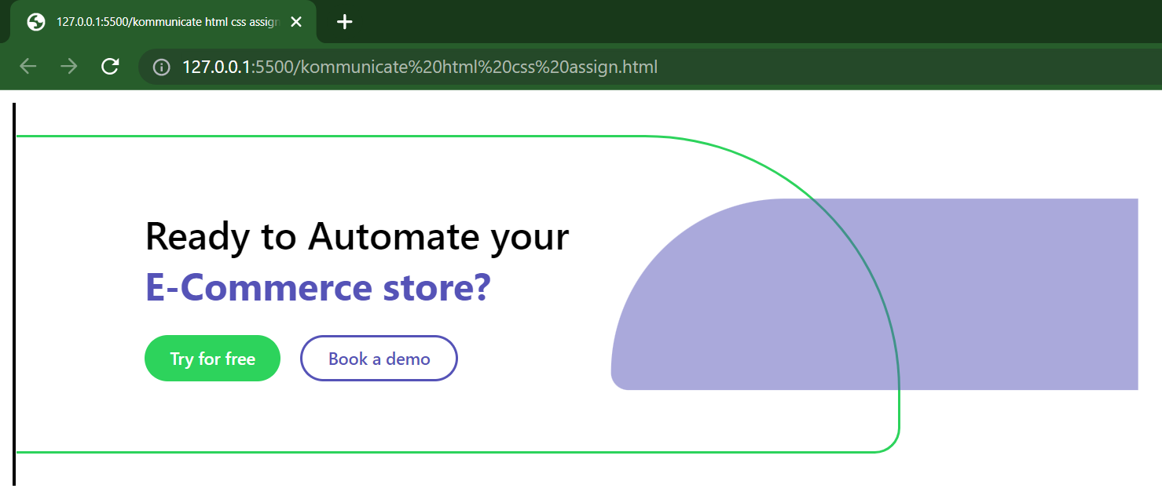

2. Complete the following javascript function that accepts the url and the parameter name and returns the value of that parameter.

Solution:

Code

var url = "https://www.kommunicate.io/poweredby?utm_source=https://www.kommunicate.io/&utm_medium=webplugin&utm_campaign=poweredby";

var params = "utm_medium";

function getUrlParameterValue(url, parameter) {

return new URL(url).searchParams.get(parameter);

}

console.log(getUrlParameterValue(url, params));

output screenshot

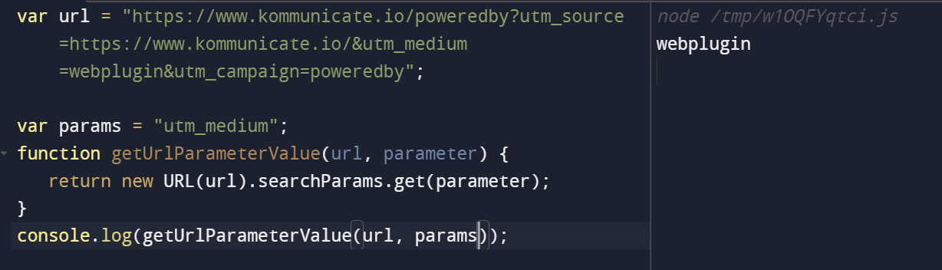

3. Write a javascript function that prints the reverse of a number. Example: if the number is 149, then output should be 941.

Code

let num = 149;

function reverseDigits(num) {

let rev_num = 0;

while(num > 0)

{

rev_num = rev_num * 10 + num % 10;

num = Math.floor(num / 10);

}

return rev_num;

}

console.log(reverseDigits(num));

output screenshot

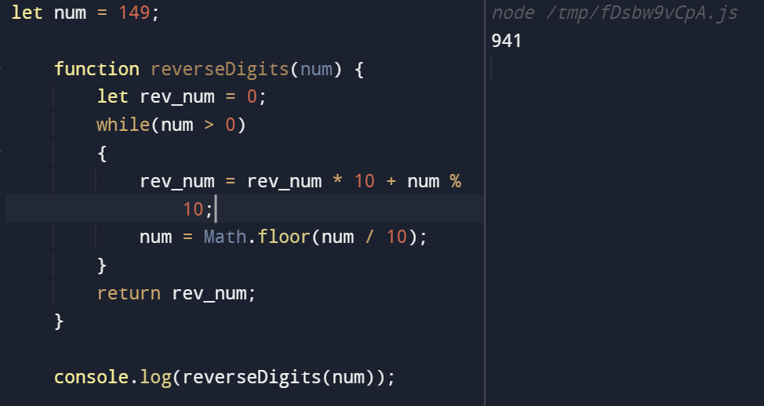

4. Describe the best project you have worked on, including links if any.

Project 1: ***CompiCenter***

It Is a Platform to Practice Questions on Different Competitive Websites with Lot of Features Like Category Wise Questions on Cod forces. You Can Also Find Company Wise Problems on Company Page.

**Link-**

**https://compicenter.vercel.app/**

Project 2:

It is a Chat web application used to solve the problems of the multiple customers having the same issue.

Using this, one operator can handle the multiple customers and solve their problem at a time who are having similar or same issue.

**Link-**

https://multi-chat-customer-support-anil-app.netlify.app/

5. If you are to start a software company, name 2 people from your batch whom you will choose as your partner and why?

Solution:

If I am going to start a software company then I will make Shivam Singh and Satwik Thakur as my partner.

Because Satwik Thakur’s communication skill is very very good and he is always handle the problem in easy way and

Shivam singh is technically very strong and have never give up attitude.